**TERMS OF REFERENCE**

**SENIOR CLIMATE CHANGE ADAPTATION CONSULTANT**

## **BACKGROUND:**

The process to address climate change adaptation planning has always been a priority for the Maldives. In the beginning, climate change, and particularly adaptation has been mainly included in the National Environmental Action Plans. In 2006, the National Adaptation Program of Action (NAPA) was officially launched, targeting to address, mainly the short-term adaptation needs of the country. Since then, mainstreaming climate change adaptation into national development has become the usual practice for the government. In this regard, the National Development Plans and Strategic Action Plans of the successive governments have considered climate change adaptation and resilience building as one of the priorities of their action plans. The Climate Change Policy Framework launched in 2015, provided strategic guidance to address adaptation needs of the country and the importance for mainstreaming adaptation and resilience building in the sectoral planning process. The first Climate Change Act (Climate Emergency Act) enacted in 2021, encompasses the broader climate policies of the state and has made a broader framework and provisions to reduce vulnerability to the impacts of climate change, by building adaptive capacity and resilience, and to build short, medium- and long-term adaptation planning processes and resilience building in the country.

To further strengthen the national adaptation planning process, Maldives has initiated its National Adaptation Plan development process together with UN Environment in 2016, aiming to mobilize Green Climate Fund Readiness Programme support to develop the country’s NAP. This support was mobilized in 2023. Since then, the Climate Change Department of the Ministry of Climate Change, Environment and Energy together with UN Environment is working to prepare climate risk assessments and tasks assigned under the GCF Readiness supported NAP of the Maldives[1]. The project will also enhance stakeholder engagement, including gender representation, social inclusiveness and engagement of vulnerable groups and communities.

In expediting the Maldives’ NAP preparation works, the Ministry is seeking NAP Global Network’s support to enhance the process by recruiting a national expert service. The proposed Senior Climate Change Adaptation Consultant is expected to provide support to the climate change department to advance national adaptation planning and implementation. The Consultant is also expected to facilitate the sectoral consultation process with line-Ministries, Agencies, Councils and also with the private sector, mainly to strengthen the integration of climate change adaptation into sectoral plans and development processes. The support will further help to identify the sectoral needs and priorities to mobilize public funds and prioritize the investment opportunities on adaptation and resilience building initiatives. It will also facilitate the Ministry in securing resources for implementation of the NAP from international sources.

## **OBJECTIVES:**

The main objective of the assignment is to provide support and technical input for advancing the NAP process of the Maldives towards its successful implementation through sectoral participation.

## **KEY TASKS:**

Under the guidance of the climate change department focal point, the consultant is expected to conduct the following tasks.

1. Support the coordination works of the NAP process

* Prepare frameworks to ensure engagement of all stakeholders in the NAP development process including government, non-governmental, community based and private sector agencies.
* Where possible identify and build synergies with ongoing planning process within different sectoral agencies towards integration of climate change adaptation and resilience building, including the agencies responsible for gender, family and social services.
* Based on available data and literature, develop a draft model of vertical integration, which incorporates risk hazard mapping, climate models, and vulnerability assessments to inform Maldives NAP process.
* Provide support and technical inputs for organizing stakeholder consultations, reginal workshops and technical expert meetings.
* Support organizing NAP national consultation meetings.

1. Provide technical inputs on drafting the NAP

* Prepare technical papers in all relevant components that will be identified as key areas to be included in the NAP. The papers will act as guidance documents to prepare key strategies and actions to be included in the NAP.
* Support preparation of draft NAP framework in reference to available COP decisions and where possible international best practices.
* Support in preparation of summaries for policy makers on NAP components, NAP framework and where possible draft NAP.
* Draft a monitoring and reporting system in line with Maldives NDC that helps to tracks progress in Maldives NAP process.

1. Resource mobilization

* In consultation with climate finance unit of the CCD, identify possible donor agencies including bilateral, multilateral and climate funds and prepare a draft framework to mobilize resources in order to implement NAP strategies and actions.
* Prepare project concept notes on 2 priority areas to be identified to mobilize resources to reduce vulnerability to the impacts of climate change, by building adaptive capacity and resilience.

1. Knowledge management and communication

* Facilitate communication and outreach activities related to the NAP process, including with social media platforms of the Ministry.
* Prepare regular progress reports on NAP process and share with government agencies and if required with donors.
* Support develop of knowledge products and information materials to be prepared under the NAP process.
* Draft a monitoring, learning and evaluation (MLE) framework.

The expert is expected to integrate gender equality and social inclusion considerations throughout the above activities.

## **DELIVERABLES:**

The consultant shall submit monthly reports by the last day of each calendar month that included the following:

* Work activities and deliverables completed during the reporting period.
* Observations of emerging lessons from the NAP process during the reporting period.
* Work plan for the upcoming reporting period, including expected timelines and deliverables to be provided by the consultant.

## **TIMELINE:**

The consultant will be recruited for an initial period to June 30, 2025, with possibility of extension to April 30, 2026.

## **QUALIFICATIONS**

The applicant is expected to fulfill the following requirements

* At least 5 years of work experience in a field related to climate change, sustainable development, public policy and any other area relevant to climate or public policy
* At least three years of experience working on climate change adaptation in the context of development policies, national planning and programs in the Maldives
* Master’s degree or higher in climate change, environmental studies or any other related field
* Familiarity with the climate and development policy context of the Maldives.
* Understanding of the NAP process and related international commitments.
* Technical knowledge on climate change adaptation and links to national sustainable development.
* Excellent Dhivehi and English language skills
* Previous experience in policy formulation and facilitation is considered a strong asset.

## **DUTY STATION**

## Climate Change Department, Ministry of Climate Change, Environment and Energy, Male’,

## Maldives

## **EXPECTED START DATE:**

To be started at 1 November 2024

## **APPLICATION PROCESS:**

Interested and qualified individuals are invited to submit their cover letter, CV (maximum 4 pages), two (2) professional references, and financial proposal for this assignment to [info@napglobalnetwork.org](mailto:info@napglobalnetwork.org) with the subject line “Application for Senior Climate Change Adaptation Advisor.”

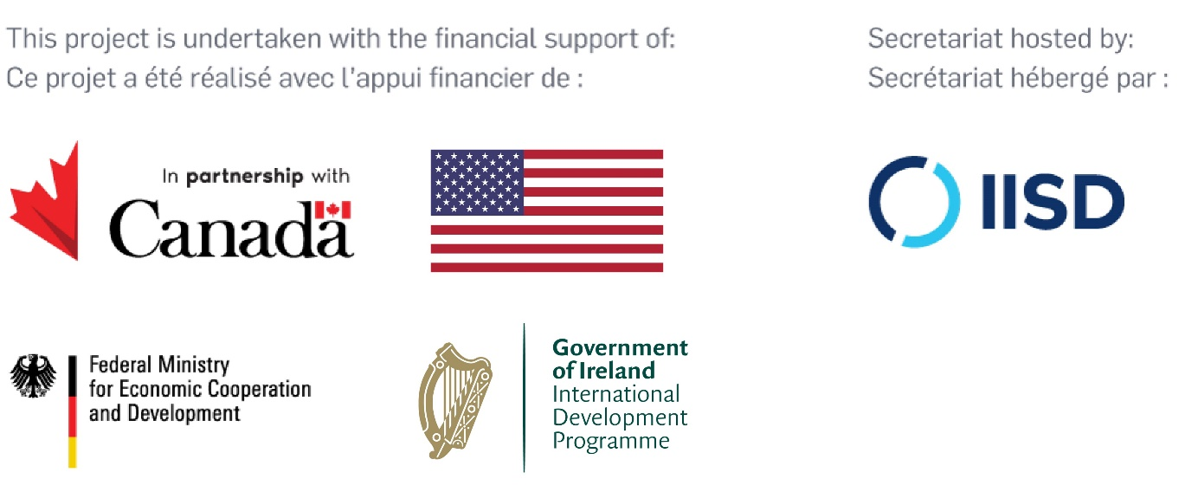

1. https://www.greenclimate.fund/document/advancing-national-adaptation-plan-maldives